Role Profile
Role Title | Senior Multi-Skilled Operative | If you would like this information in another format please contact:  Cormac Head Office  Western Group Centre  Radnor Road  Scorrier  TR16 5EH  recruitment@cormacltd.co.uk
Business Division | Construction & Property
Grade | COR10
Report to (role title) | Supervisor
Version | 1
Date Job Evaluated | 20 July 2026
Job Code | 000732
Financial | Direct financial accountability: £  Indirect financial accountability: £
People Management | Number of direct reports: 0  Number of indirect reports: 0 - May coach apprentices from time to time
Working Conditions | ☐No unusual hazards (less than 20% of the time)  ☐Minimum precautions required (more than 20% of the time)  ☐Some precautions required (more than 50% of the time)  ☒Precautions required (more than 75% of the time)
Physical Activity | ☐Minimal ☐Light  ☒Moderate ☐Heavy
Work Demands (tick all that apply) | ☒Work to deadlines ☒Frequently changing  ☒Managing conflicting priorities ☐Not normally interrupted or subject to change
Work Context | ☐No/minimal risk to personal safety ☐Potential risk to personal safety  ☒Moderate risk to personal safety ☐Substantial risk to personal safety
Role Purpose
To undertake high-quality multi-skilled repairs, maintenance, building, installation and improvement works across Cornwall in support of responsive, planned and minor works delivery while providing day-to-day task leadership, technical guidance and compliance assurance in support of responsive, planned and minor works delivery. The postholder will apply a core trade qualification together with broad multi-trade capability to deliver safe, compliant and customer-focused works across a varied property portfolio.

The role supports the effective delivery of the Construction & Property business plan by working closely with Supervisors, colleagues and specialist subcontractors, making efficient use of labour, materials, plant and company assets, and maintaining a strong focus on right-first-time delivery, health and safety, customer care and value for money.

The role does not carry formal line-management authority unless this is specifically delegated. Matters involving formal performance management, disciplinary action, appraisals or formal employee dispute resolution remain the responsibility of an authorised Supervisor or Manager.

The role will be required to undertake the allocation of resources and coordination within CORMAC teams to provide support across the specified delivery area in meeting the objectives within the CORMAC business plan.
About the role
- Deliver responsive repairs, planned maintenance and minor improvement works across domestic, commercial and public-sector properties within Cornwall.
- Use a primary trade qualification together with broader multi-trade competence to complete a wide range of maintenance, installation, alteration and finishing activities.
- Work independently or as part of a team to plan daily tasks, assess work areas, identify materials and equipment requirements, and complete jobs safely and efficiently.
- Support Supervisors with day-to-day coordination by providing progress updates, identifying follow-on works, flagging risks, and helping to maintain programme delivery.
- Maintain a professional and customer-focused approach when dealing with clients, tenants, members of the public, subcontractors and internal teams.
- Contribute to a positive safety culture by following RAMS, site rules and permit requirements, reporting hazards and near misses, and challenging unsafe behaviour where necessary.
- Use mobile technology and company systems to record labour, materials, variations, job status and completion information accurately and in a timely manner.
- To deliver the project pipeline of planned, maintenance and improvement works.
- To ensure that all workers and sub-contractors are suitably trained, competent and certificated in line with Corserv and required Minor Works and CDM Regulations.
- To ensure that work is completed in full accordance with current regulation, to client requirements and meeting principal contract specifications.
- To maintain confidentiality of information acquired in the course of undertaking duties for the Company.
- To be aware of and adhere to applicable rules, regulations, legislation and procedures e.g., County Council (Equal Opportunities Policy/Code of Conduct), national legislation (Health and Safety, Data Protection).
- To be responsible for your own continuing self-development, undertaking training as required.
What you'll be doing
• Undertake multi-skilled repairs, maintenance and improvement works to the required quality standard, in accordance with the issued work order, specification and client requirements.
• Carry out pre-start checks, dynamic risk assessments and safe isolate on / protection measures as required, ensuring that work areas remain safe for operatives, occupants and the public.
• Operate in compliance with applicable legislation, company procedures and site-specific controls, including the Health and Safety at Work etc. Act, CDM requirements, PUWER, COSHH and manual handling requirements, where relevant.
• Use appropriate personal protective equipment, tools, plant and access equipment, ensuring all items are checked before use and defects are reported immediately.
• Accurately record and submit timesheets, job sheets, material requests, PDA / handheld updates, variations, photographic evidence and completion records.
• Deliver a high-quality, customer-focused service, maintaining good housekeeping and minimising disruption to building users and other stakeholders.
• Identify when specialist support or subcontract input is required and escalate through the Supervisor in a timely manner.
• Support, coach and set a positive example to apprentices and colleagues, sharing good practice and maintaining expected standards of workmanship and behaviour.
• Manage impressed vehicle stock, tools, plant, spares and consumables responsibly, ensuring items are secure, serviceable and used in accordance with company policy.
• Drive and use company vehicles in accordance with company rules, highway legislation and daily vehicle check requirements.
• Undertake work efficiently and cost effectively, minimising waste, non-productive time and rework, and reporting delays or delivery issues promptly to the line manager.
• Maintain confidentiality of information obtained in the course of employment and comply with company requirements relating to data protection, equality, conduct and customer care.
• Report accidents, incidents, near misses, unsafe conditions and defects promptly and support continual improvement in risk management and service delivery.

• To follow instructions as required to fulfil the works required as reasonably particular.

• Work collaboratively with supervisors, support teams and operatives to maintain continuity of service and resolve day-to-day delivery issues.

• Provide accurate progress updates, identify delays or conflicting priorities early, and support practical replanning to protect safety, service standards and client commitments.

• Support positive working relationships and address minor operational misunderstandings appropriately; escalate interpersonal disputes, conduct concerns or formal employee matters to an authorised Supervisor or Manager rather than undertaking formal mediation.

• Maintain confidentiality, data protection, equality, conduct and customer-care standards, and act as a professional representative of Cormac when dealing with clients and the public.

• Participate in the out-of-hours emergency call-out arrangements where required and approved.

• Carry out documented van compliance checks covering vehicle condition, safe loading and load restraint, storage, stock levels, material suitability, segregation and security of hazardous substances, availability of COSHH assessments / safety data information, and waste carrier / transfer documentation where applicable.

• Complete routine visual checks of vehicle and site fire extinguishers, confirming accessibility, condition, tamper seals and service status, and refer servicing, discharge or replacement to an approved competent provider.

• Check first-aid boxes at an appropriate frequency, ensuring contents are suitable, complete, in date and replenished, and report any wider first-aid provision concerns.

• Carry out recorded checks of PPE and work equipment for condition, suitability, inspection / test status and compliance; quarantine defective or out-of-date items and arrange escalation. Technical inspection, maintenance or electrical testing must only be undertaken where trained and authorised.

• Manage impressed vehicle stock, tools, plant, access equipment, spares and consumables responsibly, minimising loss, damage, waste and avoidable reordering.

• Undertake and record formal ladder and stepladder inspections in accordance with the company inspection regime, normally at intervals not exceeding three months and following any event that may have affected safety. Ensure pre-use checks remain the responsibility of each user and remove defective equipment from service.

• Ensure operatives and subcontractors use the appropriate PPE, tools, plant, access equipment and control measures for the task, and challenge unsafe behaviour constructively.

• Prepare sufficiently detailed scopes, material schedules and quotations, including assumptions, access requirements, risks and exclusions, for management review.

• Use company systems to record labour, materials, variations, job status, inspections, photographs and completion information accurately and promptly.

Qualifications and Experience | Recruitment and Selection
Possess or has the ability and willingness to achieve a relevant City and Guilds Craft or equivalent in a core trade certification. | Application Form Interview Certification
Demonstrates comprehensive technical skills in several core trades demonstrating a broad experience of building construction and maintenance. | Application Form Interview
Evidence of competence of 3 or more trades in construction and maintenance skills – e.g. Carpentry, Plastering, Roofing, Kitchen and bathroom fitting etc. | Application Form Interview Certification
Awareness of relevant building codes, legislation, regulation and policies. | Application Form Interview
Demonstrates a sound understanding and working knowledge of the Health & Safety at Work Act. | Application Form Interview
CSCS Card holder or equivalent. – To be Removed | Certification
Demonstrates good written, social and interpersonal skills with the ability to communicate well. Ability to identify problems with clients, subcontractors and third parties and to seek a resolution. | Application Form Interview
To participate as part of the 24-hour,7 day a week, Out of Hours emergency call out team as required. | Application Form Interview
CSCS card or equivalent. SSSTS or equivalent supervisory safety training is desirable, or willingness to achieve within an agreed period. | Application Form Interview
Ability to inspect defects, scope works, produce measurements and material requirements, and prepare clear and sufficiently detailed quotations. | Application Form Interview

Other requirements
Full Valid driving licence |  | YES
The duties of the role involve travel on a regular basis. It is a condition of employment that the role holder can exercise satisfactory travel mobility in order to fulfil the obligations of the role. For those journeys where an alternative form of transport is unavailable or impracticable the role holder will be required to provide a suitable vehicle. |  | YES
This role has been identified by the organisation as safety critical |  | YES
This role is politically restricted |  | NO
This post is subject to overtime (where approved/appropriate) |  | YES
This post is subject to the Company’s Flexitime Scheme (manager discretion) |  | NO
This post is subject to a criminal records disclosure check |  | YES - ENHANCED
Approving Manager | Jack Spittal
Approving Business Divisional Head | Ben Fallowes
Approving Director | Ben Fallowes
Date | 10/07/2026 – Draft for review

Our values

Our values shape everything that we do across our Group. From construction to care services, from travel to transport and everything else in between.

Our values guide the way we work with our business partners, within our communities and with each other.
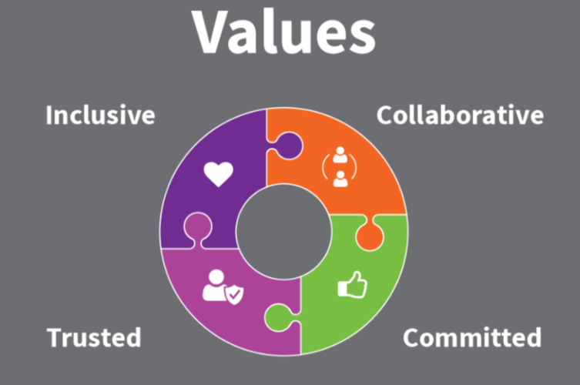

Collaborative | we work with and support each other to serve our communities.
Committed | we are unwaveringly dedicated to being the best at everything we do.
Trusted | we are open and honest and do what we say we’ll do.
Inclusive | we are considerate and respectful of our people and the communities/environment we work in.

