Role Profile
Role Title | Asset Replacement Coordinator | if you would like this information in another format please contact:  Cormac Head Office  Western Group Centre  Radnor Road  Scorrier  TR16 5EH  recruitment@cormacltd.co.uk
Business Division | Fleet and Workshops
Grade | Cor8
Report to (role title) | Asset Replacement Manager
Version | V1
Date Job Evaluated | <to be entered by Cormac JE Panel>
Job Code | 000455
Financial | Direct financial accountability: £  Indirect financial accountability: £100,000
People Management | Number of direct reports: 0  Number of indirect reports: 0
Working Conditions | ☐No unusual hazards (less than 20% of the time)  ☒Minimum precautions required (more than 20% of the time)  ☐Some precautions required (more than 50% of the time)  ☐Precautions required (more than 75% of the time)
Physical Activity | ☐Minimal ☐Light  ☒Moderate ☐Heavy
Work Demands (tick all that apply) | ☒Work to deadlines ☒Frequently changing  ☒Managing conflicting priorities ☐Not normally interrupted or subject to change
Work Context | ☐No/minimal risk to personal safety ☐Potential risk to personal safety  ☒Moderate risk to personal safety ☐Substantial risk to personal safety
Role Purpose
To coordinate the replacement of fleet and mechanical equipment whilst assisting in the transition to alternatively fuelled vehicles for CORSERV (and Cornwall Council).
Ensuring principles of best value are met and that the Company and Council has access to safe and modern vehicles and equipment.
About the role
As a member of the replacement team, you will take a lead role on the fleet and mechanical equipment replacement programme working to ensure adherence to the asset management strategy, you will support the renewal, review, and use of procurement frameworks (and other routes to compliant procurement) within current and predicted future budgetary constraints and demand pressures.

There will be a requirement to provide data support on asset replacement and alternative fuel related matters and to work in close partnership with, group and council departments and external partners to provide both in person, and remote, subject matter expertise (SME) across the business, in relation to asset replacement, transition to alternative fuel vehicles and technical knowledge.

What you'll be doing
- Act as the Lead role in the renewal, review and use of plant and mechanical equipment procurement frameworks working in close consultation with procurement colleagues.
- Undertake the procurement of a wide variety of Fleet and Mechanical Equipment from initial design, development of specification, award, and order, through to the management of build and asset introduction.
- Utilise and update various IT systems and portals with asset information across the Fleet department, including (but not limited to) Tranman, Proactis, Quartix, Evotix, Workday, Fleet Intranet and SharePoint etc.
- Collate new asset certification for fleet and mechanical equipment "Asset Files" ensuring compliant content (COC, type approval, PDI's, operator and parts manuals etc.).
- Undertake the invoice process in relation to the timely payment of invoices for new assets ensuring validity, consistency and compliance with financial regulations.
- Undertake the handover of new fleet and mechanical equipment and provide user training, instruction and guidance including all approved documentation.
- Responsibility for the safe keeping and security of new vehicles and those due for disposal, including the inspection of newly delivered vehicles, the issue and receipt of vehicle keys to internal workshops/contractors undertaking preparation and decommissioning tasks.
- To arrange and document customer replacement "dashboard" meetings ensuring close consultation with operational teams and drivers in relation to replacement prioritisation and specification agreement.
- Work in partnership with the Logistics Hub and Customers to ensure optimisation of re-allocation of surplus vehicles across the Group.
- Responsible for the collation of certification for end-of-life fleet and mechanical equipment ensuring asset files and I.T. systems etc. are updated accordingly whilst working in close consultation with the Fleet Compliance Team.
- Coordinate the decommission and disposal of end of life/time expired fleet and mechanical equipment ensuring maximum income is achieved.
- To deliver and arrange training, toolbox talks and provide advice to operational teams across the group, relating to current and new fleet and mechanical equipment with emphasis on goods vehicle operator licence and health & safety compliance.
- Act as subject matter expert (S.M.E.), in internal and external meetings relating to the transition towards alternatively fuelled vehicles across the group, both regionally and nationally (CREST, Transition board, community groups and seminars etc.).
- Influencing decision making around operational changes required to expand the introduction of alternatively fuelled vehicles and the infrastructure required for said change.
- Support the implementation of the company and Council strategy for transition to alternatively fuelled vehicles.
- To work with colleagues and Private Sector partners on the installation of alternative fuel infrastructure including (but not limited to) Bio-methane fuelling stations and electric vehicle charge points etc. Act as subject matter expert (S.M.E.) to support investigations relating to fleet and mechanical equipment incidents in partnership with the Fleet Compliance and SHEQ teams.
- Produce management information for board, transport managers and operational managers in relation to the replacement of group fleet and mechanical equipment (Asset condition, replacement programme status, financial commitment and spend, transition to alternative fuel and CO2 emissions etc.).
- Undertake customer fleet and mechanical equipment assessments and evaluations (suitability, performance, H&S) and arrange demonstrations with manufacturers, suppliers and customers to ensure correct operational and compliance asset choice.
Other Tasks:
- Support the application processes relating to grants available for use in the transition to alternatively fuelled vehicles and/or purchase of ultra-low emission vehicles.
- To keep up to date with the evolving nature of alternative fuel strategy and industry changes through regular contact with regional fleet operators and national agencies such as Logistics UK, Department of Transport, DVSA etc.
- Contribute to current and future improvements across the Fleet department.
- Support the Asset Replacement Manager and Head of Fleet with the review and renewal of replacement processes.

Qualifications and Experience | Recruitment and Selection
The following qualifications and experience are essential:  Qualified to SVQ Level 3 in Business & Administration or similar qualification or equivalent experience. | Application Form Interview
Full Valid Driving Licence (Category B) | Application Form Interview
Experience of Fleet Replacement Programmes including review and use of procurement frameworks (and other routes to compliant procurement) ensuring compliance with financial regulations. | Application Form Interview
Understanding of regulations and requirements pertaining to vehicle maintenance and driver compliance. | Application Form Interview
Working knowledge of vehicle/driver legislation and codes of practice. | Application Form Interview
Demonstrates sufficient knowledge and skill to examine, interpret and extract information plus organise it in an appropriate format for analysis | Application Form Interview
Working knowledge of Health & Safety at Work Act etc. and other relevant legislation and regulations. | Application Form Interview
Experience of using asset management software (e.g., Tranman). | Application Form Interview
Experience of using performance management software (e.g., Power BI). | Application Form Interview
Experience of working in a team environment. | Application Form Interview
Experience of working in a reactive and fast paced environment. | Application Form Interview
Ability to communicate well in written, spoken and electronic formats. | Application Form Interview
Ability to communicate complex subject matter in an easy-to-understand format (know your audience). | Application Form Interview
Good interpersonal skills. | Application Form Interview
The following qualifications and experience are desirable:  Driving Licence (Category C and Driver Qualification Card) | Application Form Interview
Knowledge of alternatively fuelled fleet and mechanical equipment, their introduction operationally and related environmental improvements. | Application Form Interview
IOSH Managing Safely or similar qualification or equivalent experience (or be prepared to work towards). | Application Form Interview
Proficient in the use of all Microsoft applications (Word, Excel PowerPoint etc.). | Application Form Interview
Willing to work flexibly to accommodate operational requirements of the role (seminar attendance, financial year end processes, emergency situations etc.) | Application Form Interview
Knowledge of alternatively fuelled fleet and mechanical equipment, their introduction operationally and related environmental improvements. | Application Form Interview

Other requirements
Full Valid driving licence |  | YES
The duties of the role involve travel on a regular basis. It is a condition of employment that the role holder can exercise satisfactory travel mobility in order to fulfil the obligations of the role. For those journeys where an alternative form of transport is unavailable or impracticable the role holder will be required to provide a suitable vehicle. |  | YES
This role has been identified by the organisation as safety critical |  | NO
This role is politically restricted |  | NO
This post is subject to overtime (where approved/appropriate) |  | NO
This post is subject to the Company’s Flexitime Scheme (manager discretion) |  | NO
This post is subject to a criminal records disclosure check |  | NO  BASIC/ENHANCED  CHILD/ADULT
Approving Manager | Robert Pooley
Approving Business Divisional Head | Adrian Millward
Approving Director | Bruce Robb
Date | January 2026

Our values

Our values shape everything that we do across our Group. From construction to care services, from travel to transport and everything else in between.

Our values guide the way we work with our business partners, within our communities and with each other.

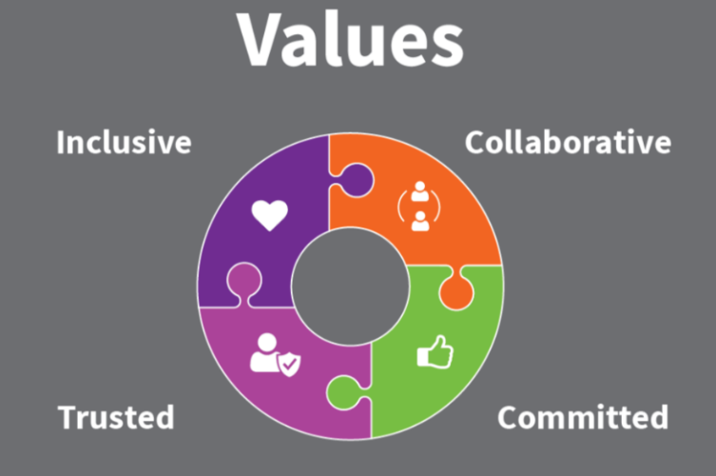

Collaborative | We work with and support each other to serve our communities.
Committed | We are unwaveringly dedicated to being the best at everything we do.
Trusted | We are open and honest and do what we say we’ll do.
Inclusive | We are considerate and respectful of our people and the communities/environment we work in.

