Role Profile
Role Title | Digital Content, Communications and Engagement Apprentice  Level 3 | if you would like this information in another format please contact:  Cormac Head Office  Western Group Centre  Radnor Road  Scorrier  TR16 5EH  recruitment@cormacltd.co.uk
Business Division | Highways and Environment
Grade | Apprenticeship Grade
Report to (role title) | Social Value, Communications and Engagement Lead
Version | 1
Date Job Evaluated | 19 May 2026
Job Code | 000706
Financial | Direct financial accountability: None  Indirect financial accountability: None
People Management | Number of direct reports: None  Number of indirect reports: None
Working Conditions | ☒No unusual hazards (less than 20% of the time)  ☐Minimum precautions required (more than 20% of the time)  ☐Some precautions required (more than 50% of the time)  ☐Precautions required (more than 75% of the time)
Physical Activity | ☐Minimal ☒Light  ☐Moderate ☐Heavy
Work Demands (tick all that apply) | ☒Work to deadlines ☒Frequently changing  ☒Managing conflicting priorities ☐Not normally interrupted or subject to change
Work Context | ☒No/minimal risk to personal safety ☐Potential risk to personal safety  ☐Moderate risk to personal safety ☐Substantial risk to personal safety
Role Purpose
This is an exciting opportunity to be supported through the Level 3 Content Creator Apprenticeship Standard whilst working for Cormac, gaining a Level 3 qualification and experience in communication and engagement. You will be supported and mentored by the wider communication and engagement team throughout your programme, alongside attending one of our training provider partners.
This role will support stakeholder and customer-focused communications and engagement activities through the planning, creation, management and evaluation of high-quality written, visual and audio content. As part of the communications and engagement team, you will contribute to the delivery of internal and external communications plans and campaigns, ensuring content is audience-focused, accessible, compliant, and aligned with Cormac’s brand and business objectives.
The role will play an important role in helping connect Cormac with stakeholders, residents, and existing and potential clients, driving engagement, increasing reputation, and growing internal and external communications channels.
About the role
The apprenticeship role sits within the communications and engagement function, providing support across the Highways and Environment Term Service Contracts, which deliver highways and environmental management and maintenance activities on behalf of Cornwall Council.
- To work collaboratively with internal teams, including operations, human resources, customer services and senior management, as well as external partners and suppliers.
- Support day-to-day activity across multiple channels, platforms and relevant systems.
- Support current and emerging technologies, software and systems which impact communications and engagement.
- Work is primarily office or remote-based but may involve attending exhibitions, events, meetings, and supporting engagement and research activities.
- To maintain the confidentiality of information acquired in the course of undertaking duties for the business.
- To be aware of and adhere to applicable rules, regulations, legislation and procedures.
- To be responsible for your own learning and development as part of the apprenticeship.
What you'll be doing
- Contribute to communications and engagement plans and campaign delivery.
- Interpret briefs, brand guidelines, and objectives to plan content activity.
- Research audiences, insights, and data to inform campaign and content decisions.
- Create, source and edit written, visual and audio content for multiple channels.
- Adapt content for different audiences, platforms and stakeholder needs.
- Proofread and quality-assure content to ensure accuracy, accessibility and brand compliance.
- Support publishing, monitoring and engagement across digital platforms.
- Store and manage content securely using approved tools and systems.
- Support administrative duties as required, such as organising meetings, maintaining records and coordinating team activities.
- Monitor analytics and compile performance reports to inform improvements.
- Work ethically and legally, including compliance with copyright, General Data Protection Regulation (GDPR) and accessibility standards.
- Identify and respond to emerging technologies, platfforms and trends.
- Work collaboratively with internal and external stakeholders to support delivery of campaigns.
Qualifications and Experience | Recruitment and Selection
Essential  - Interest in communications, engagement and content creation  - Strong written/verbal communication skills  - Attention to detail, care in spelling, grammar and formatting  - Time management – ability to prioritise tasks and meet deadlines  - Teamwork – ability to work with the wider team and stakeholders to develop content  - Willingness to complete Level 2 English and Maths if not already achieved  Desirable  - Experience using digital tools, social platform or Microsoft Office software  - Awareness of analytics, website or social metrics  - Basic skills in image or video editing tools | Application Form Interview Certification
Ability to work collaboratively with others and act professionally | Application Form Interview Certification
Takes responsibility, shows initiative and is organised | Application Form Interview Certification
Ability to work flexibly and adapt to circumstances | Application Form Interview Certification

Other requirements
Full Valid driving licence |  | YES
The duties of the role involve travel on a regular basis. It is a condition of employment that the role holder can exercise satisfactory travel mobility in order to fulfil the obligations of the role. For those journeys where an alternative form of transport is unavailable or impracticable the role holder will be required to provide a suitable vehicle. |  | YES
This role has been identified by the organisation as safety critical |  | NO
This role is politically restricted |  | NO
This post is subject to overtime (where approved/appropriate) |  | NO
This post is subject to the Company’s Flexitime Scheme (manager discretion) |  | YES
This post is subject to a criminal records disclosure check |  | YES - BASIC
Approving Manager
Approving Business Divisional Head | Andy James
Approving Director | Andy James
Date

Our values

Our values shape everything that we do across our Group. From construction to care services, from travel to transport and everything else in between.

Our values guide the way we work with our business partners, within our communities and with each other.

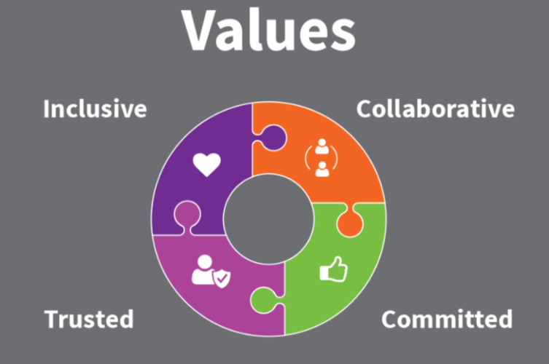

Collaborative | We work with and support each other to serve our communities.
Committed | We are unwaveringly dedicated to being the best at everything we do.
Trusted | We are open and honest and do what we say we’ll do.
Inclusive | We are considerate and respectful of our people and the communities/environment we work in.

