Role Profile
Role Title | Associate Project Manager | if you would like this information in another format please contact:  Cormac Head Office  Western Group Centre  Radnor Road  Scorrier  TR16 5EH  recruitment@cormacltd.co.uk
Business Division | CORMAC Solutions Ltd
Grade | CECS9
Report to (role title) | Technical Director
Version | 1.2
Date Job Evaluated | 31 March 2026
Job Code | 000695
Financial | Direct financial accountability: £ 12M  Indirect financial accountability: £ 60M
People Management | Number of direct reports: 3 to 5  Number of indirect reports: 0
Working Conditions | ☒No unusual hazards (less than 20% of the time)  ☐Minimum precautions required (more than 20% of the time)  ☐Some precautions required (more than 50% of the time)  ☐Precautions required (more than 75% of the time)
Physical Activity | ☒Minimal ☐Light  ☐Moderate ☐Heavy
Work Demands (tick all that apply) | ☒Work to deadlines ☒Frequently changing  ☒Managing conflicting priorities ☐Not normally interrupted or subject to change
Work Context | ☐No/minimal risk to personal safety ☒Potential risk to personal safety  ☐Moderate risk to personal safety ☐Substantial risk to personal safety
Role Purpose
To lead Project Management associated with £60M Design and Construction Projects. This involves representing the business working with the Engineering Design Group (Highways and Civils, Structures, Geotech) staff, Cormac Business Directors, Capital Projects Team, Cornwall Council Client Managers, External Consultants, Contractors and Statutory Undertakers, Elected bodies and the public. The role has significant impact on Services Provision and Organisational reputation.

About the role
- To undertake, manage and coordinate all aspects of Project Management including:
- Create, own, and implement Project Management Processes to ensure the consistent delivery of projects to cost and time
- Ownership and management of complex and varied £12M Annual Programme, often involving prioritization of Need based on political and deliverability considerations. Requires political sensitivity and knowledge. Major political implications if not delivered.
- Cost Monitoring / Management of Projects incl. use of CEMAR, or similar
- Production of Annual, Quarterly and Monthly Reports for use by Technical Director and ELT Management
- Production of Weekly / Monthly reports for use by Teams to manage their portfolios
- Management of sub-Consultants and sub-Contractors wrt contract deliverables and costs. Dealing with often contentious issues and resolving them in a professional and sensitive manner
- Management of Early Warnings and Compensation Events. Use of rationale and debating skills to convince / persuade others of our position
- Co-ordination of stakeholder management with Public, Councilors, Council staff, local business, local interest groups
- Organise, manage and minute ECI meetings. Act as interface between client, design, commercial, operational teams
- Performance management including sub-consultant / contractor reviews and leading on lessons learned reviews
- To control all projects in accordance with design budgets and / or fees and to agreed timescales
- To supervise the day to day work of project staff
- To deal directly with project client on all administration, progress and financial matters
- To deal directly with Elected Members, the Public and relevant external bodies in order to conduct appropriate consultants
- To prepare formal reports and write Committee items
- To comply with the requirements of the Business management system, e.g. QA, Safety, Environmental, Training
- To be aware of and adhere to applicable rules, regulations, legislation and
- procedures eg CORMAC Solutions (Equal Opportunities Policy/Code of Conduct), national legislation (Health and Safety, Data Protection)
- 9 To maintain confidentiality of information acquired in the course of undertaking duties for the business
- To be responsible for your own continuing self-development, undertaking training as required
- To undertake other duties appropriate to the grading of the post as required.

What you'll be doing
- All of the above

Qualifications and Experience | Recruitment and Selection
Degree Qualified in relevant subject  Member of the Association of Project Management (MAPM)  NEC 3, NEC 4 ECC Project Management Qualification  Experience of managing a skilled technical team  Proven project management skills, ability to monitor project progress and finances  Confident oral and written communication skills  Financial and commercial awareness  Proven ability to successfully manage projects and lead project teams in a Local Authority, Consultancy, and Contracting background  Displays good interpersonal skills, empathy and patience when dealing with customers. Has detailed knowledge of tools and techniques for dealing with challenging behaviours | All the below: Application Form Interview Certification

Other requirements
Full Valid driving licence |  | YES
The duties of the role involve travel on a regular basis. It is a condition of employment that the role holder can exercise satisfactory travel mobility in order to fulfil the obligations of the role. For those journeys where an alternative form of transport is unavailable or impracticable the role holder will be required to provide a suitable vehicle. |  | YES
This role has been identified by the organisation as safety critical |  | NO
This role is politically restricted |  | NO
This post is subject to overtime (where approved/appropriate) |  | NO
This post is subject to the Company’s Flexitime Scheme (manager discretion) |  | YES
This post is subject to a criminal records disclosure check |  | TBC
Approving Manager | Nick Carter
Approving Business Divisional Head | Andy James
Approving Director | Andy James
Date | 31/03/2026

Our values

Our values shape everything that we do across our Group. From construction to care services, from travel to transport and everything else in between.

Our values guide the way we work with our business partners, within our communities and with each other.

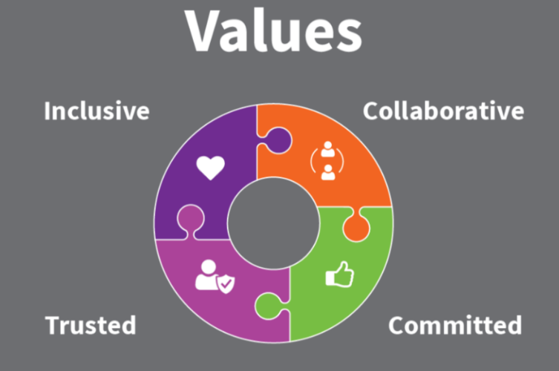

Collaborative | we work with and support each other to serve our communities.
Committed | we are unwaveringly dedicated to being the best at everything we do.
Trusted | we are open and honest and do what we say we’ll do.
Inclusive | we are considerate and respectful of our people and the communities/environment we work in.

