Role Profile
Role Title | Assistant Cleaning Manager | if you would like this information in another format please contact:  Cormac Head Office  Western Group Centre  Radnor Road  Scorrier  TR16 5EH  recruitment@cormacltd.co.uk
Business Division | Soft Services
Grade | COR8
Report to (role title) | Cleaning Services Manager
Version | 2.0
Date Job Evaluated | 19.12.25
Job Code | 000667
Financial | Direct financial accountability: £  Indirect financial accountability: £40,000.00
People Management | Number of direct reports: 60  Number of indirect reports: 70
Working Conditions | ☐No unusual hazards (less than 20% of the time)  ☐Minimum precautions required (more than 20% of the time)  ☒Some precautions required (more than 50% of the time)  ☐Precautions required (more than 75% of the time)
Physical Activity | ☐Minimal ☐Light  ☒Moderate ☐Heavy
Work Demands (tick all that apply) | ☒Work to deadlines ☒Frequently changing  ☒Managing conflicting priorities ☐Not normally interrupted or subject to change
Work Context | ☐No/minimal risk to personal safety ☒Potential risk to personal safety  ☐Moderate risk to personal safety ☐Substantial risk to personal safety
Role Purpose
Working closely with the Cleaning Services Managers, Facilities Managers, Facilities Coordinator, assigned Site Supervisors and cleaning staff the role will support the Cleaning Service operational delivery across the county.
The role will interact with a cross section of clients including County Council managers, Head Teachers, School Governors, Town & Parish Councils and Housing Associations

About the role
- To support the Cleaning Services Manager by understanding the requirements of each allocated contract ensuring they are delivered safely, in line with operating procedures, accreditation, polices and best practice.
- To ensure all Specifications/Schedules are being met in order to ensure high levels of client satisfactions reporting potential issues to the Cleaning Manager.

- To maintain confidentiality of information acquired in the course of undertaking duties for the Company.
- To be aware of and adhere to applicable rules, regulations, legislation and procedures e.g., County Council (Equal Opportunities Policy/Code of Conduct), national legislation (Health and Safety, Data Protection).
- To be responsible for your own continuing self-development, undertaking training as required.

What you'll be doing
- What you'll be doing
- To supervise the allocated workforce ensuring effective service delivery including:
- Ensure that Site Supervisors are fully trained to supervise their cleaning staff and to implement cost effective training plans.
- Reporting vacancies to the Cleaning Services Manager and supporting the recruitment & selection of new staff, when required
- Induction and management of probation periods for new employees ensuring safe working methods, competence and skills to undertake the tasks required together with sufficient knowledge of the client requirements. Notify Learning and development Team of new starter with competed induction record.
- Identify training needs and refer to Cleaning Services Manager
- Accurate recording of overtime and absence and leave
- To work with Cleaning Services Manager/Scheduler to ensure all leave/vacancies are covered by mobile team – reporting back if any gaps in service
- To carry out return to work interviews ensuring the absence is recorded referring to the Cleaning Services Manager where appropriate.
- To assist with the Implementation of performance management and monitoring systems
- To regularly visit all allocated sites, ensuring regular communication with cleaners, especially lone workers.
- To ensure all allocated sites have adequate materials and consumables
- To undertake water temperature checks in respect of legionella testing.
- To undertake portable appliance testing.
- To work with the Cleaning Services Manager to seek innovation, increase productivity and drive efficiencies on all allocated contracts
- Deal with service failures & complaints in a timely and effective manner to avoid financial penalties
- To ensure the Quality Management Systems are maintained across allocated contracts, through an active monitoring/auditing process ensuring meaningful data is collated
- To continually strive to build good business relationships with customers and to respond to their needs and to provide management services to customers not requiring full cleaning services
- To market and actively promote Cleaning Services in order to secure opportunities to grow the business.
- To respond to emergencies, when necessary, in respect of accident, failure, break-ins, vandalism, weather and other needs
- To undertake various administrative and clerical tasks
- To be aware of and adhere to applicable rules, regulations, legislation and procedures e.g. CORMAC (Equal Opportunities Policy/Code of Conduct), national legislation (Health and Safety, Data Protection)
- To maintain confidentiality of information acquired in the course of undertaking duties for the Department
- To be responsible for personal continuing self-development, undertaking training as required
- To undertake other duties appropriate to the grading of the post as required

Qualifications and Experience | Recruitment and Selection
NVQ2 in a related service capacity or experience of working in a related service area | Application Form Interview Certification
Has sufficient knowledge and ability to supervise staff in a Cleaning service environment, demonstrates proven IT skills ( Assessment | Application Form Interview Certification
Previous work experience in cleaning/facilities related work in an office, school/college or industrial environment. | Application Form Interview Certification
An understanding of H&S in the workplace including carrying out risk assessments | Application Form Interview Certification
Demonstrates the ability to work under own initiative within operational guidelines | Application Form Interview Certification
Diplomatic and personable and has the ability to be assertive when required | Application Form Interview Certification
Has sufficient knowledge and skills to be able to deal with the public effectively, observe confidentiality and maintain dignity | Application Form Interview Certification
The normal duties of this role will involve the requirement to work shifts which will include early starts, late finishes, weekend and bank holiday working and it is a condition of employment that you exercise satisfactory level of flexibility in order to fulfil the objectives of the role | Application Form Interview Certification
Position requires a certain amount of manual handling, lifting and carrying, candidates will have knowledge of manual handling techniques and an ability to lift and carry small items | Application Form Interview Certification

Other requirements
Full Valid driving licence |  | YES
The duties of the role involve travel on a regular basis. It is a condition of employment that the role holder can exercise satisfactory travel mobility in order to fulfil the obligations of the role. For those journeys where an alternative form of transport is unavailable or impracticable the role holder will be required to provide a suitable vehicle. |  | YES
This role has been identified by the organisation as safety critical |  | YES
This role is politically restricted |  | NO
This post is subject to overtime (where approved/appropriate) |  | YES
This post is subject to the Company’s Flexitime Scheme (manager discretion) |  | NO
This post is subject to a criminal records disclosure check |  | YES  BASIC/ENHANCED  CHILD/ADULT
Approving Manager | Mel Omlo
Approving Business Divisional Head | Tracy Westaway
Approving Director | Ben Fallowes
Date | 18/12/2025

Our values

Our values shape everything that we do across our Group. From construction to care services, from travel to transport and everything else in between.

Our values guide the way we work with our business partners, within our communities and with each other.

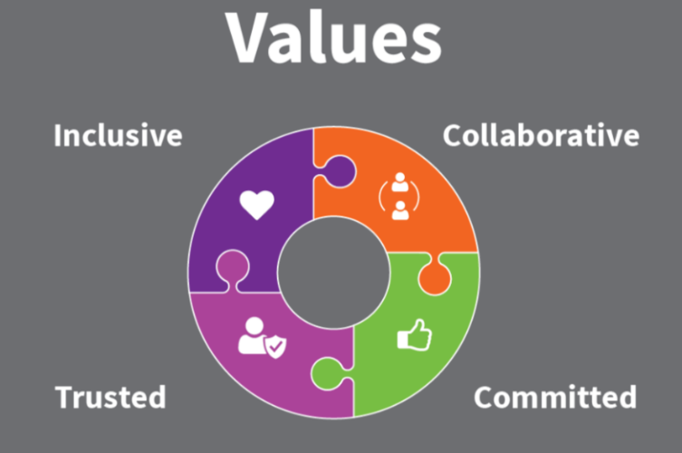

Collaborative | we work with and support each other to serve our communities.
Committed | we are unwaveringly dedicated to being the best at everything we do.
Trusted | we are open and honest and do what we say we’ll do.
Inclusive | we are considerate and respectful of our people and the communities/environment we work in.

