Role Profile
Role Title | Highway Development and Infrastructure Manager | if you would like this information in another format please contact:  Cormac Head Office  Western Group Centre  Radnor Road  Scorrier  TR16 5EH  recruitment@cormacltd.co.uk
Business Division | Term Service Business
Grade | Cor 15
Report to (role title) | Business Director – Term Service Contracts
Version | 1.0
Date Job Evaluated | 11 June 2026
Job Code | 000711
Financial | Direct financial accountability:  - £1.5m approval and inspection fees annually for delivery of new infrastructure projects  - £10m annually for S278 highway works delivered by the council via developer contributions  - £100k typically recovered under the S38/S278 default process for the completion of sites prior to adoption.  Indirect financial accountability:
People Management | Number of direct reports: 1 x Principal Estates Adoption Officer, 2 x Principal Development Officers  Number of indirect reports: 15 indirectly within immediate team. Up to 50 indirectly dependent upon the post holder for decision making and guidance.
Working Conditions | ☒No unusual hazards (less than 20% of the time)  ☐Minimum precautions required (more than 20% of the time)  ☐Some precautions required (more than 50% of the time)  ☐Precautions required (more than 75% of the time)
Physical Activity | ☒Minimal ☐Light  ☐Moderate ☐Heavy
Work Demands (tick all that apply) | ☒Work to deadlines ☒Frequently changing  ☒Managing conflicting priorities ☐Not normally interrupted or subject to change
Work Context | ☒No/minimal risk to personal safety ☐Potential risk to personal safety  ☐Moderate risk to personal safety ☐Substantial risk to personal safety
Role Purpose
To provide strategic leadership across highways development management and adoptions, ensuring new infrastructure is planned, approved, delivered and integrated into Cornwall’s highway asset consistently, efficiently and in line with long-term service and asset objectives.

The role will:

- Provide clear strategic leadership across the highways development management and adoptions functions, strengthening accountability, consistency, performance and joined-up working across teams and stakeholders
- Improve the quality, consistency and timeliness of highways input to development and adoption, ensuring planning, technical approval, inspection, agreement and adoption processes deliver robust outcomes, appropriate mitigation and timely progression of completed infrastructure into adoption
- Establish and develop positive working relationships with developers, consultants, Cornwall Council colleagues, and other stakeholders to support effective collaboration, clear communication and confidence in service delivery
- Lead service improvement within the delivery remit by developing processes, procedures, systems and ways of working that improve efficiency, transparency and performance, while providing operational feedback to inform future policy, standards and guidance where required

About the role
The Highway Development Manager role has been established to provide clear strategic leadership across the Council’s highways development management and adoptions functions, at a point where there is increasing need for consistency, stronger coordination and improved confidence in how new infrastructure is planned, assessed, approved and brought forward. The role provides a clearer focus for aligning highways input to development with the Council’s wider priorities for sustainable growth, infrastructure delivery and long-term asset stewardship.
The post sits within a client-led policy framework, where overall strategy and policy are set by the Council. Within that framework, the role is intended to shape and strengthen the operational delivery model, leading the development of processes, systems, standards and ways of working that improve performance, support sound decision-making and create greater clarity for internal teams, developers and delivery partners.
The role is also intended to strengthen the interface between planning, infrastructure delivery, adoption and wider strategic investment, ensuring that highways considerations are addressed in a coordinated and proportionate way from the earliest stages of development through to final delivery and acceptance. In doing so, the post provides a key point of leadership for improving service effectiveness, supporting the delivery of strategic projects and ensuring that infrastructure accepted into the network is appropriate, compliant and capable of supporting long-term public value.

What you'll be doing
- Lead the highways development management and adoptions service, ensuring policies, standards and guidance are applied consistently and effectively
- Lead the development and continuous improvement of highways development management and adoption specifications, processes, procedures and systems within the delivery remit, supporting service improvement and providing operational feedback to inform National and local policy, standards and guidance where required
- Lead and manage the Highway Development Management team, ensuring planning applications and transport impacts are assessed consistently and that robust advice and appropriate mitigation are secured through the planning process
- Lead and manage the Highways Adoptions team, ensuring Section 278, Section 38 and related processes, agreements, technical approvals, inspections and adoption activities are applied consistently and concluded in a timely and proportionate manner
- Set clear expectations, priorities and performance standards, promoting accountability, continuous improvement and customer focus across the teams
- Manage the budgets associated with the highways development management and adoptions service, ensuring effective financial planning, monitoring and control, value for money, and appropriate use of resources in support of service and infrastructure delivery objectives
- Lead negotiations with developers on highway works, transport contributions and related obligations through Section 278, Section 38 and Section 106 arrangements, as appropriate, to support effective infrastructure delivery and appropriate mitigation
- Manage Council-delivered Section 278 works undertaken on behalf of developers, ensuring effective governance, value for money, appropriate risk management and increased developer confidence in delivery
- Ensure effective coordination between developer-funded highway works, including Section 278 schemes, and the Council’s wider capital programme, supporting efficient delivery, reduced disruption and alignment with long-term asset objectives
- Ensure the design, delivery, handover and transition of capital project infrastructure into the highway asset take proper account of future maintenance requirements, asset owner views and the information needed to support effective ongoing maintenance and asset management
- Ensure highway infrastructure is assessed, approved and coordinated in line with national and local policy, programme requirements and long-term asset management objectives
- Lead coordination across relevant services, delivery partners and external stakeholders in relation to developments affecting strategic projects and initiatives, ensuring effective collaboration and joined-up delivery
- Oversee statutory processes, including APC, PSWC and Highway Stopping Up, ensuring legal requirements are met, appropriate action is taken, formal processes are instructed where required and representation is provided at court where necessary
- Provide specialist professional advice on highways development and adoption matters to Members, officers, developers and other stakeholders
- Support the achievement of the Council’s wider objectives by aligning new infrastructure delivery with corporate priorities and by working collaboratively across services to make effective use of resources
Qualifications and Experience |  | Recruitment and Selection
Educated to degree level in a relevant discipline |  | Application Form
Relevant professional qualification and/or membership of an appropriate professional body |  | Application Form
Significant experience of highways and civil engineering activities including the design and delivery of infrastructure projects |  | Application Form  Interview
Demonstrable understanding of relevant legislation and policy relating to the construction and adoption of highway infrastructure including S278 and S38 of the Highways Act 1980 |  | Application Form  Interview
Proven track record of success in building effective working relationships and working collaboratively across varying engineering disciplines to achieve the delivery of infrastructure projects |  | Application Form  Interview
A working knowledge of planning legislation, specifically interfaces within the Council as Planning and Highway Authority |  | Interview
Demonstrable leadership experience with the ability to manage and empower teams to achieve and deliver |  | Interview
Demonstrable track record of working on own initiative and seeking pragmatic solutions to problems. |  | Interview
Excellent interpersonal, written and oral skills |  | Application Form  Interview
Other requirements
Full Valid driving licence |  | YES
The duties of the role involve travel on a regular basis. It is a condition of employment that the role holder can exercise satisfactory travel mobility in order to fulfil the obligations of the role. For those journeys where an alternative form of transport is unavailable or impracticable the role holder will be required to provide a suitable vehicle. |  | YES
This role has been identified by the organisation as safety critical |  | NO
This role is politically restricted |  | NO
This post is subject to overtime (where approved/appropriate) |  | NO
This post is subject to the Company’s Flexitime Scheme (manager discretion) |  | NO
This post is subject to a criminal records disclosure check |  | NO
Approving Manager | Andy James
Approving Business Divisional Head | Andy James
Approving Director | Andy James
Date | May 2026
Our values

Our values shape everything that we do across our Group. From construction to care services, from travel to transport and everything else in between.
Our values guide the way we work with our business partners, within our communities and with each other.
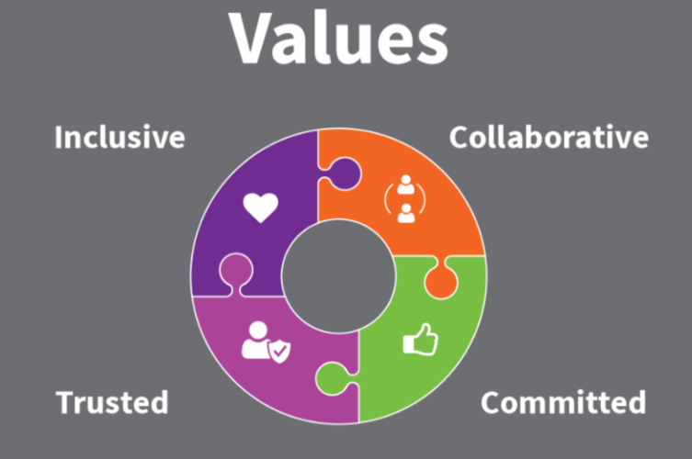

Collaborative | we work with and support each other to serve our communities.
Committed | we are unwaveringly dedicated to being the best at everything we do.
Trusted | we are open and honest and do what we say we’ll do.
Inclusive | we are considerate and respectful of our people and the communities/environment we work in.

